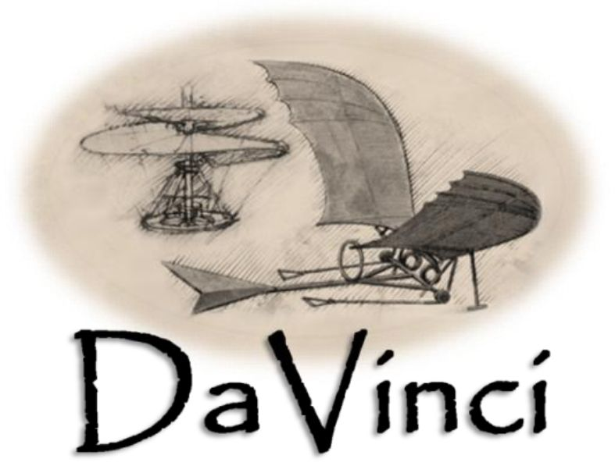
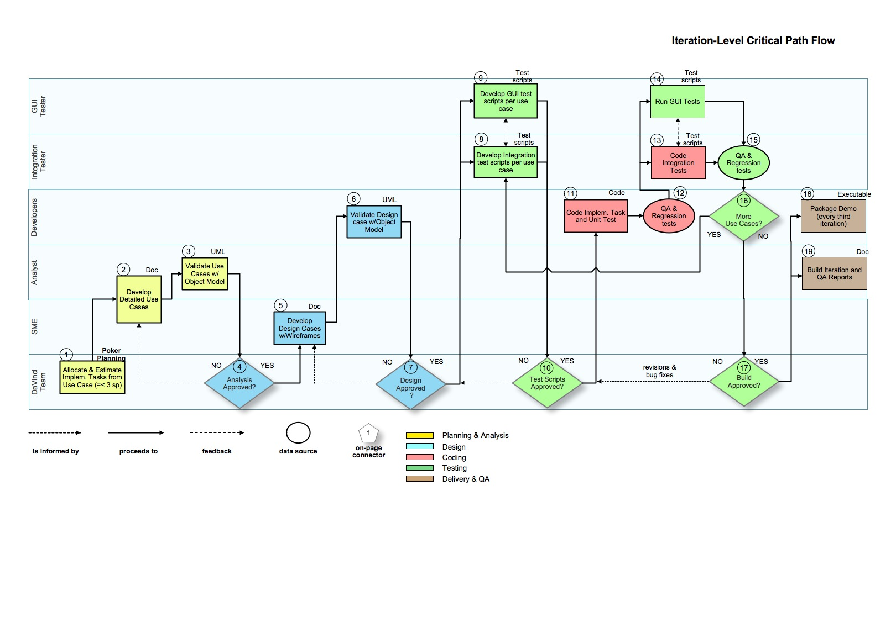
Computational-Based Engineering for Conceptual Design
CREATE-AV Program
DaVinci 2.0
Software Engineering Approach
Version 2.0
February 10, 2012

Distribution Statement
Distribution Statement C: Distribution authorized to U.S. Government Agencies and their contractors due to Administrative or Operation Use as determined on 24 February 2010. Other requests for this document shall be referred to ASC/XRE, 1970 Monahan Way, WPAFB, OH 45433-7902.
ITAR Statement
WARNING: This document contains technical data whose export is restricted by the Arms Export Control Act (Title 22, U.S.C., Sec. 2751, et seq.) or the Export Administration Act of 1979, as amended, Title 50, U.S.C., App. 2401 et seq. Violation of these export laws are subject to severe criminal penalties. Disseminate in accordance with the provisions of DoD Directive 5230.25.

About This Document
Document Purpose
The DaVinci Software Engineering Approach document describes the agile approach used for developing the DaVinci Concept Modeler application. This approach employs a balance between rigor, speed, and short-cycle feedback consistent with the current software development culture.
Document Prepared For
Gregory L. Roth, ASC/XRE, WPAFB
DaVinci Principal Developer
Gregory.Roth@WPAFB.af.mil
Intended Audience
All members of the DaVinci software product team, particularly the technical development and testing members.
Publication Date
Last saved: March 6, 2012
This printing: 4/4/12
Page count: 19 pages
Document Location
Request from Gregory L. Roth, ASC/XRE, WPAFB
Gregory.Roth@WPAFB.af.mil
1970 Monahan Way, WPAFB, OH 45433-7902
Prepared By
Al Cline, PMP,
Contractor, Flairsoft Federal
DaVinci Software Engineering Lead
alan.cline.ctr@wpafb.af.mil

Revision History
Date | Version | Description | Modified By
08/04/2011 | 1.0 | Initial draft | Alan Cline
08/17/2011 | 1.1 | Edits and conversion to DaVinci template | Sally Schehl
2/1/2012 | 1.2 | Updated from lessons learned | Alan Cline
2/2/2012 | 1.3 | Updated from review comments | Alan Cline
2/10/2012 | 2.0 | Editing pass for clarity/style | Aaron Einhorn

Table of Contents
About This Document 3
Revision History 3
Table of Contents 5
Step 1.Software Engineering Approach and Quality Assurance 6
Step 1.Software Engineering Approach and Quality Assurance 6
1.1.Agile Approach 6
1.2.Business Planning 6
1.3.Release Planning to Iteration Planning 6
1.4.Iteration Time-Boxing 6
1.5.Iteration Process Tasks 6
1.5.1.Planning and Analysis 6
Step 2.Use Case Estimating (Planning Poker) 6
Step 3.Develop Detailed Use Cases 8
Step 4.Validate Uses Cases with Analysis Object Model 8
Step 5.Is Analysis Approved? 8
5.1.1.Design 8
Step 6.Develop Design Cases with Wireframes 8
Step 7.Validate Design Cases with Design Object Model 8
Step 8.Is Design Approved? 8
8.1.1.Testing 9
Step 9.Develop Integration Test Scripts 9
Step 10.Develop GUI Test Scripts 9
Step 11. Test Scripts Approved? 9
11.1.1.Coding 9
Step 12. Code Implementation Task and Unit Tests 9
Step 13. QA Readiness Checklist: Run QA and Regression Tests 9
13.1.1.Formal Testing 9
Step 14. Code Integration Tests 9
Step 15. Run GUI Tests 9
Step 16. Run QA and Regression Tests 10
Step 17. More Use Cases? 10
Step 18. Build Approved? 10
18.1.1.Delivery and Quality Assurance 10
Step 19. Package User Demo 10
Step 20. Write Iteration and QA Reports 10
Step 21. What is Not Shown: Code Reviews 10
21.1.1.References 11
Step 22.APPENDIX: Sample Iteration Checklist 12
Step 22.APPENDIX: Sample Iteration Checklist 12
Table 1. Detailed tasks for a single use case 12
Table 2. Rollup Checklist for multiple use cases 13

Software Engineering Approach and Quality Assurance

Agile Approach
The DaVinci Concept Modeler application will be developed using the “agile” software engineering approach. The approach used for DaVinci is more conservative than some projects would use, and employs a balance between rigor, speed, and short-cycle feedback consistent with the current development culture. The Air Force requires waterfall -style reporting at the high levels, so the EVO flavor of agile is used, which allows a clean mapping between waterfall at the annual Release level, and agile tracking and tasking at the iterative level. Each iteration is like a minor waterfall.[1]

Business Planning
At the beginning of each annual Release, the stakeholders provide capabilities that are matched against the business flows to achieve those capabilities. The business flows originate with FDAT (Functional Decomposition and Allocation Technique) diagrams and are converted into Business Process Modeling Notation (BPMN), the standard for business flow analysis because it can be used to map and verify the completeness of all the use cases desired for the system. Use cases are the major form of functional requirements around which development is based. The end result of the annual Business Planning activity is a Software Requirements Specifications (SRS) that contains stakeholders, capabilities, and a use case catalog

Release Planning to Iteration Planning
During release planning, which occurs in the up-front planning before the team begins any iteration, each known use case is allocated to a particular iteration for implementation. The stakeholders’ priorities determine which use cases are selected for a particular iteration. Each set of iteration use cases focuses on what the next user demo will display and on any functional dependencies needed by the use cases selected.
Given the use cases previously defined from the release plan, the team decides if those use cases are still appropriate for the current iteration. The use cases selected each iteration comprise the current iteration backlog; all remaining use cases not yet selected for the current iteration become the release backlog.

Iteration Time-Boxing
Error: Reference source not found shows an example of the sequence of critical work that needs to be performed within the time box of a single iteration. All work is done approximately in the order shown. Its complement, the more detailed iteration plan--shows the task, owner, duration, due date, actual start and actual finish date--provides a “checklist” of the sequence of tasks. Both of these highly visible artifacts support and promote accountability. See the Appendix for a sample iteration task checklist.

Iteration Process Tasks
Unlike the waterfall approach, each iteration within the agile approach contains analysis, design, coding, and testing tasks, as applied to the previous version of the DaVinci product. After the team has completed testing successfully, the build is delivered to the user for quality control. Each completed build should be production-ready for the scope of the current iteration.
The subsections below correspond to the boxes shown in Error: Reference source not found and detail what occurs during each portion of the iteration task flow.

Planning and Analysis

Use Case Estimating (Planning Poker)
Use case planning poker is an estimation technique used in a two-hour team meeting (Box 1, Figure 1). During this meeting, the team reaches a consensus on which case will be in the current iteration, and how long each use case will take to validate, code, test, and document. New use cases or dependencies can be added at this point.
Scope is represented in arbitrary units called story points. Each member of the team “votes” each use case an arbitrary number of points: 1, 2, 3, 5, 8, or 13. These numbers are NOT associated to hours of work, but are used to describe the size of use cases (design, coding, testing, and documenting) relative to each other. The estimate for each use case is the consensus value for the whole team. When that value stabilizes, the use case is marked with that number of story points. Each use case is best broken into subtasks of three or fewer story points that can be completed within a single day.

Figure : Iteration-Level Critical Path Flow.

Spikes. Sometime is it difficult to assign fewer than 13 points to a complete use case, or a use case’s scope is unknown. Investigations must be performed to see how to break it down, or to research a new technique or programming interface, or to identify some other problem. In that case, that activity is called a spike, and the time assigned to investigate the spike is treated like a use case for scheduling purposes, and given a number of story points also. Spikes are never more than one day long, and count toward the total number of points in the current iteration.
Pins. Sometime is it is difficult to decompose a use case into tasks no larger than three points. Unlike spikes, pins refer to delaying the breaking down of the use case until after design validation (but before coding). Before the use case is implemented, however, it must be allocated into tasks of three points or less, and assigned to a developer.

Develop Detailed Use Cases
The analyst and the requirements subject matter expert (SME) expand each use case targeted for implementation during the current iteration into a detailed use case (Box 2, Figure 1), which is the functional requirements specification captured on a use case form. The use case form is compliant with the IEEE 830 standard for requirements specification [4]. The detailed use case contains a step-by-step dialogue (normal path, possible alternative path, and error paths) between the actor (user or external system) and the application, and defines all the input and output data. A typical use case is between one and two pages long.
A use case is technology-independent; the detailed use case is a platform-independent model (PIM) of the problem domain of the application. The detailed use case does not contain design information for this step unless it is specifically designated as a requirement. The detailed use case explains WHAT the user wants, but not HOW the system will implement it.
Wireframes are views to the user showing how the use case data is input or output, and these are truly design artifacts. However, they are so useful for the use case understanding that they are attached with the detailed use case, either as the last step of analysis, or as the first step of design.

Validate Uses Cases with Analysis Object Model
The analyst builds an analysis object model as a quality-control effort to ensure that the platform-independent software architecture and detailed use case description are consistent and provably correct (Box 3, Figure 1)Error: Reference source not found. The object model is a scope-of-control decomposition of the application’s problem domain. The analyst builds two UML artifacts that describe the domain of the use case:
A UML class diagram for the problem domain component, which is a scope-of-control decomposition of the software components and classes.
A UML sequence diagram that executes (simulates) the use case through the class diagram.
When the class diagram and sequence diagram (scope-of-control description) are consistent with the detailed use case (functional description) for data source and identification, object behavior, and message relationships, the use case and object model are correct. Changes to the use case or object model may be necessary to complete the validation.

Is Analysis Approved?
The team reviews the analysis model to verify that 1) the analyst made no mistakes,
2) all cases of interest are covered, and 3) the developers have enough information to proceed further through the iteration (Box 4, Figure 1). If not, the detailed use case and the associated object model are revised and team-reviewed until the analysis model passes. Once the team approves the analysis model, they can proceed into the design part of the iteration.

Design

Develop Design Cases with Wireframes
The SME also defines the wireframes (user interface artifacts, such as screen widgets, report layouts, etc.) and includes their navigational relationships. The SME often consults the requirements analyst or usability expert for this portion of the step.
The developers will define the design cases in conjunction with the requirements analyst and SME (Box 5, Figure 1). The design case is the detailed use case elaborated for design features and includes the technologies that the analysis model does not.
As mentioned in the Analysis section, sometimes wireframes are included with the use case to augment the use case validation.

Validate Design Cases with Design Object Model
The application design is technology-dependent and defines the implementation classes for the problem domain component, as well as the other components of the application. The developers expand the platform-independent analysis model into a platform-specific model (PSM) to define the implementation (Box 6, Figure 1) for all components and modules, and more detailed data and behavior are defined. Expansion occurs as a result of adding the implementation classes to the PDC, and adding the concrete and implementation classes to the other components (HIC, CIV, DMC, and SIC). The design model can be three to ten times more complex than the analysis model. See the Application Design Document [7].
The developer builds an XUML sequence diagram [5] simulating the detailed design use case against the design-level class diagrams at the implementation level. Inconsistencies between those three elements (class diagram, sequence diagrams, design use case) indicate an error.

Is Design Approved?
The team reviews the design model to verify that it is correct and complete, and that they have enough information to proceed further through the iteration (Box 7, Error: Reference source not found). If not, the design model (design use cases and associated object model) is revised and team-reviewed until it does pass. Once the team approves the design model, they can proceed into the testing part of the iteration.

Testing

Develop Integration Test Scripts
The integration tester converts the validated detailed use case into test scripts, which are text documents that define all the steps, expected results, and execution paths for the use case (Box 8, Error: Reference source not found). Each test script is required to comply with the NEBS method (normal, error, boundary, and special execution paths through the use case) for deriving test cases from use cases.
All integration scripts are written to exercise the full use case, excluding the GUI widgets. The integration test starts at the input CIV component just “behind” the GUI widget, exercises the use case paths through the system, and collects the test result from the output CIV object.
Integration test classes are written in JUnit and executed by “plugging into” the CIV at the proper point in the use case thread. See the DaVinci Application Architecture Report [7] for a description of these components, and how the JUnit testing tool interfaces with DaVinci.)
It is useful for the integration test script writer and the GUI test script writer to compare tests when each are finished because the test scripts execute the same code in the back end, and one tester often thinks of tests that other does not.

Develop GUI Test Scripts
At the same time the integration tester begins writing integration test scripts, the GUI tester converts the same validated detailed use cases into GUI test scripts (Box 9, Error: Reference source not found). The GUI test scripts are text documents that define all the steps, expected results, and execution paths to exercise the GUI widgets and user-experience artifacts. Each test script is required to comply with the NEBS method (normal, error, boundary, and special execution paths through the use case) for deriving use cases into test cases. The integration test scripts inform the GUI test scripts.
It is useful for the GUI test script writer and the integration test script writer to compare tests when each are finished because the test scripts execute the same code in the back end, and one tester often thinks of tests that other does not.

Test Scripts Approved?
The team reviews the integration and GUI test scripts for NEBS case coverage and any other testing paths they might think necessary (Box 10, Error: Reference source not found). If the test scripts are complete and accurate, the developers move on to writing the code (Box 11, Error: Reference source not found) for the test scripts. If not, the team must repair the GUI and/or integration scripts.

Coding

Code Implementation Task and Unit Tests
If the use case has not been divided previously, the developer breaks the use case into relevant tasks of no more than three story points, or what can be accomplished and submitted to SVN in one day, Almost always the human interface (GUI), problem domain, and data management components are involved in the same use case. The use case is best implemented as a thin thread from system end-to-end at full production quality level.
The developer writes the implementation code with associated JUnit tests (Box 11, Error: Reference source not found). The correct API has already been captured in the design model (Box 6, Error: Reference source not found), although small changes often occur between design and coding. A JUnit test is written to test a very small part of a class method (target method), and the code is then written to pass that test. The test is augmented to test a larger part of the method, and this process continues until all tests and objects are completed.
Per DaVinci standards, the JUnit code for unit testing is commented with Javadoc QA tags to assist the QA tool for reporting and test assurance. Each tag describes the kind of unit test (one of the NEBS cases defined in the GUI and integration tests). All passing unit tests are added to the current test suite to ensure their availability in later regression testing. The code must also comply with the Java coding style standards, which is monitored by the Checkstyle tool. See the relevant standard documents for details [8,9,10]

QA Readiness Checklist: Run QA and Regression Tests
When the developer is finished coding each use case, he runs the full-automated regression test suite that contains all integration and unit tests from previous iterations, and the Checkstyle support tool that monitors code standards (Box 12, Error: Reference source not found). The developer also runs the QA tool to ensure that all code methods have sufficient JUnit tests. If 100% of the regression suite passes, the developer checks the code into the shared codebase in Subversion (SVN).
If any defects are found in the code, a new test is written, the code is repaired, and the regression suite is run again. After all defects are repaired and have tests, the new code is submitted to SVN. The DaVinci team requires that each developer submit working code at least once per day.
Part of the QA Readiness Checklist is that DaVinci be tested on each of the platforms on which DaVinci must run: Windows 7, Windows Vista, Linux Fedora, CentOS, and Mac OS X, version 10.6 or later. If possible, it should be run on Windows XP because so many people have requested that platform, but no official Change Request has been signed off.

Formal Testing

Code Integration Tests
The integration tester writes the JUnit code (Box 13, Error: Reference source not found) to implement the integration test scripts (Box 8) written earlier. All of the implementation unit tests should have passed the regression suite, so the integration code will also pass, unless there is a defect in the connection between the object, or the tester thought of a case that the developer did not (or, unhappily, the Build failed the QA Readiness Checklist and was not ready to send to QA). The Integration tester compiles the test results report and submits it to the QA manager.

Run GUI Tests
The GUI tester executes the tests (Box 14) according to the GUI test scripts (Box 9, Error: Reference source not found) written earlier. Often, the GUI tester will wait until the integration test is completed because the code base may change. There is no code to write for GUI testing. The GUI tester compiles the test results report and submits it to the QA manager.

Run QA and Regression Tests
As in step 12, the integration tester runs the QA and regression suites to ensure that the new code written as a result of repairing defects found during formal testing works in context for the entire application (Box 15, Error: Reference source not found). If 100% of regression testing passes, the target code and the test code are submitted to SVN.

More Use Cases?
The process flow from Box 8 through Box 15 applies to a single use case under development and is broken into one to three story points. If there are more use cases (Box 16, Error: Reference source not found), the developer and integration tester repeat the flow until either all use cases are completed, or the iteration runs out of time. Any remaining use cases are left as carryovers for the next iteration.

Build Approved?
When all use case implementation and testing is complete, or the iteration manager determines that the build must move on, the team meets to decide if the build is ready enough to close the iteration (Box 17, Error: Reference source not found). At this point, all product code is written, unit tested, integration tested, GUI tested, and regression tested. The team review mostly ensures that all tests have passed. If not, the build is repaired, which entails repeating the tasks in steps 11 through 16.

Delivery and Quality Assurance

Package User Demo
For DaVinci, a user demo is scheduled after every third iteration for the user to assess progress (Box 18, Error: Reference source not found). User demos are scheduled between iterations to provide preparation time.
After the team approves the completed build, the developers prepare the install package (use cases and test cases contained within the build, all necessary libraries, executables, install scripts, configuration files, etc.) and distribute it to remote users. The principal developer prepares a few presentation slides or a demo video for the stakeholders who wish to see DaVinci’s progress.
Users can install the latest build on their machines for testing (or review it remotely). The build is executed for select users, and feedback is incorporated into change requests if needed. If all goes well, the users approve the iteration for inclusion in the release. Any outstanding issues or incidents are resolved with the Change Management Board (the development team in DaVinci’s case), not shown in Error: Reference source not found.
The technical writer (not shown in Error: Reference source not found) writes the next corresponding chapter(s) of the user manual based on the use cases it contains.

Write Iteration and QA Reports
The QA manager (shown as the analyst in Error: Reference source not found because the QA manager also is the analyst for DaVinci), has tracked and coordinated the activities for the build, monitored the defects and incidents, and processed any change requests that occurred, throughout the iteration. After the iteration completes, all QA reports and iteration statistics are compiled and delivered (Box 19, Error: Reference source not found).
At the end of the iteration, the QA manager produces the following reports:
QA Report: Dashboard statistics on scope, cost, schedule, and quality, and compared with previous iterations. The results show as GREEN/YELLOW/RED status.
Burn down Chart: The number of story points completed for use cases and carryovers, the average velocity for the team, and various performance statistics. Any Change Requests that add scope to the iteration are also reflected.
Unified Object Model: At the end of each iteration, all use cases, UX artifacts, analysis and design object models are packaged together. Also, each use case’s object model (class diagrams and sequence diagrams) are added to a comprehensive object model for the entire application (all use cases).
Updated Requirements Traceability Matrix (RTM): The use cases, UX artifacts, and test cases, are added to the existing RTM for traceability, mapped into the original capability requirements against the use case catalog.
After the iteration is closed, and the optional user demo is over, the poker planning session is scheduled for the next iteration, and the process flow shown in Error: Reference source not found repeats. For DaVinci Release 2.0, all iterations are scheduled in a fixed time box of 12 days, so the dates iterations start and end are previously known.

What is Not Shown: Code Reviews
Code reviews are best practices and required by some methodologies. The DaVinci team has offered forth the following reasons to not conduct code reviews:
- The code is functionally different enough that other developers would take too long to understand what is being accomplished, for example, some modules are in a different language;
- The analyst performs a code walkthrough by himself (and writes subsequent bug reports if needed) in building the Unified Object Model, and that is sufficient;
- Enough validation is done within the iteration process not to need another control mechanism.

However, this decision to avoid code reviews is coming under reconsideration for several reasons:
- Argument (a) against code reviews seems to be false because of argument (b) against code reviews (see above): if the analyst can understand well enough, then so can the developers.
- Occasional code walkthroughs have found that the standards have been violated and refactoring or repairing code has taken longer than necessary, implying that perhaps argument (c) against code reviews is also false.
Consequently, the DaVinci team will start selected section of code for review, and see if this makes a difference to quality or schedule going forward. If it does, the code review step can be added in the next Software Engineering Approach revision.

References
[1] Project Management the Agile Way, John Goodpasture, PMP, J Ross Publishing, 2010
[2] Writing Effective Use Cases, Alistair Cockburn, 2000,
[3] Object-Oriented Software Engineering: A Use Case Driven Approach, Ivar Jacobson, Addison-Wesley, 1992
[4] IEEE 830 Standards, 830-1998 - IEEE Recommended Practice for Software Requirements Specifications
[5] Extended Unified Modeling Language (XUML) for Use Case Validation, Al Cline, PMP, Flairsoft Federal, 2011.
[6] DaVinci 2.0 Solution Architecture Report (SAR), version 1.0, Eric Dabbachi, January, 2012
[7] DaVinci 2.0 Application Architecture Report, version 2.0, Eric Dabbachi, Al Cline, forthcoming
[8] Java Programming and Style Standard, Al Cline, Flairsoft Federal, May, 2010.
[9] Javadoc Documentation Standard, version 1.05, Al Cline, Flairsoft Federal, January, 2011
[10] JUnit Standard, version 1.04, Al Cline, Flairsoft Federal, January, 2011.

APPENDIX: Sample Iteration Checklist

Table 1. Detailed tasks for a single use case
Use Case | Task |  |  |  | OWNER |  | Date Due | Start Date | Date Finished
B04a. Export to Kestrel -- Aerodynamic Analysis
 | Draft use case |  |  |  | jwl
 | Draft Wireframe(s) |  |  |  | jwl
 | Analyze and validate use cases (analysis package) |  |  |  | abc
 | Analysis Approved |  |  |  | team
 | Develop use case design (design package)
 | Design Approved |  |  |  | team
 | Code, unit test, and Javadoc
 | Write GUI test scripts |  |  |  | rab
 | Write Integration test scripts |  |  |  | jnh
 | 100% regression and Checkstyle testing on Linux |  |  |  | tcl
 | 100% regression and Checkstyle testing on Windows |  |  |  | rrk
 | 100% regression and Checkstyle testing on Mac
 | Build Approved for QA |  |  |  | team
 | QA testing on Linux (QA Tool, regression, Checkstyle) |  |  |  | jnh
 | Perform GUI testing on Windows (write test report) |  |  |  | rab
 | Perform GUI testing on Linux (write test report)
 | Perform GUI testing on Mac (write test report)
 | Write JUnit integration tests |  |  |  | jnh
 | Perform JUnit integration test on Linux (write test report) |  |  |  | jnh
 | Perform JUnit integration test on Windows (write test report)
 | Perform JUnit integration test on Mac (write test report)
 | Review code and add use case to UOM (seq dgm, class dgm) |  |  |  | abc
 | Update user documentation |  |  |  | TW

Table 2. Rollup Checklist for multiple use cases
Note that the critical tasks are in addition to iteration tasks that take time from the iteration timebox.
Use Case | BZ Entry |  | Task |  |  |  |  | OWNER | Duration (days) |  | Start Date | Date Due | Date Finished
Cross Iteration Tasks |  | Use Cases
 |  |  | B04a. Export to Kestrel & Helios -- Aerodynamic Analysis |  |  |  |  | team
 |  |  | B05b. Import results from Kestrel & Helios -- Aerodynamic Analysis |  |  |  |  | team
 |  |  | DEP: Refactor for RCP |  |  |  |  | team
 |  |  | Freeze Iteration for QA |  |  |  |  | team
 |  |  | Write QA and Iteration Report for Iter 22 |  |  |  |  | abc
 |  |  | Build Approved for User Demo |  |  |  |  | team
 |  |  | Build User Demo video |  |  |  |  | jwl
 |  |  | Deploy Demo video |  |  |  |  | glr
Critical Tasks
 |  |  | Cut SVN branch for next Iteration |  |  |  |  | tcl
CYO |  |  | Develop architecture document |  |  |  |  | eid |  |  | 12/9/11 | 12/21/11
CYO |  |  | UOM: Capture current object model |  |  |  |  | abc |  |  | 12/12/11 | 12/21/11
CYO |  |  | UOM: Redesign implementation of object model |  |  |  |  | ard |  |  | 12/11/11 | 12/16/11
CYO |  |  | UOM: Refactor new object model design |  |  |  |  | ard |  |  | 12/19/21 | 2/3/12
CYO |  |  | RCP: Develop RCP migration plan |  |  |  |  | tcl |  |  | 12/11/11 | 1/13/12
CYO |  |  | Build architectural plan for CIB (SWIT) |  |  |  |  | ard |  |  | 12/16/11 | 1/13/12
CYO |  |  | Define BOM for CIB (SWIT) |  |  |  |  | ard |  |  | 12/23/11 | 1/13/12
CYO |  |  | Design enterprise architecture model |  |  |  |  | eid
CYO |  |  | Write Software Requirements Specification |  |  |  |  | abc |  |  | 1/4/12 | 1/13/11

Use cases capture a typical scenario of how the user will use the application. Use cases are the lingua franca of functional requirements to emphasize usability, user perspective, and round trip functionality. Many validation techniques and development processes are based on the use case approach.[2,3]
Mathematically, a use case is defined (in words) as a function that takes an input from outside the system, evaluates the function inside the system, and returns an output to outside the system. This round trip, single thread, approach is a use case; lesser paths are subcases , and groups of use cases are workflows.
Actually XUML (Extended Unified Modeling Language) is used instead of strict UML because it is necessary to include the data flows and abstract return values of method calls. XUML is also more concise when used in this regard.[5]

